2HandBook

UI Prototype

Version 1.0

Revision History

| **Date** | **Version** | **Description** | **Author** |
| --- | --- | --- | --- |
| 13/8/2023 | 1.0 | Initial UI Prototype | All of members |
|  |  |  |  |
|  |  |  |  |
|  |  |  |  |

Table of Contents

**1. Introduction 4**

1.1 Purpose 4

1.2 Scope 4

1.3 Definitions, Acronyms, ans Abbreviations 4

1.4 References 4

**2. Patial 4**

2.1 Header 4

2.2 Navigation 4

2.3 Footer 5

2.4 Header (Logged In) 5

2.5 Cart 5

2.6 Announcement Box 6

**3. Screens 7**

3.1 Home 7

3.2 Sign up 8

3.3 Sign in 9

3.4 Payment 10

3.5 Announcement Handle (Admin) 11

3.5.1 Post an announcement 11

3.5.2 All announcements 12

3.6 Account Management (Admin) 13

3.7 Product Management (Admin) 14

3.8 Evaluate (Comment) Management (Admin) 15

3.9 All products 16

3.10 Specific products 17

3.11 Profile editing 18

3.12 My order 19

3.12.1 Successful order 19

3.13 Pending order 21

3.14 Canceled order 22

3.15 Become seller (Buyer) 23

3.16 Shop reviews (Seller) 25

3.17 Dashboard (Seller) 27

3.18 Manage products (Seller) 28

3.19 Edit product (Seller) 29

3.20 About us & Contacts 30

3.21 Shop page 31

User Interface Prototype

# Introduction

## Purpose

This document provides all the expected screens the system will display and describes the usage of each element in the display.

## Scope

Provide complete information about the expected UIs of the system.

## Definitions, Acronyms, ans Abbreviations

UC: Use-case

## References

* Vision document
* Use-case specification document.

# Patial

## Header



Description:

* Feature 1 (Logo): This is the logo of 2HandBook. When pressing on this logo button, the system will render and display the “Home” screen.
* Feature 2 (Search bar): This is the input form for search products. When inputting the keyword, name of product and pressing on the search button at the end of search bar or pressing Enter, the system will search the product, render and display “Search Result” (the same with “All Products” screen).
* Feature 3 (Sign in button and sign up button): When pressing on these buttons, the system will render and display the “Sign in” or “Sign up” screens respectively.
* Feature 4 (Cart button): When pressing on this button, the system will display the “Cart” screen as a pop-up.

## Navigation



Description:

* Feature 1 (Main navigation): The user can hover on each navigation item to show its sub navigation if it exists or click on each navigation item to move to the desired page
* Feature 2 (Sub navigation): After hovering on each main navigation, the user can select on sub navigation links to move to the desired page.

## Footer

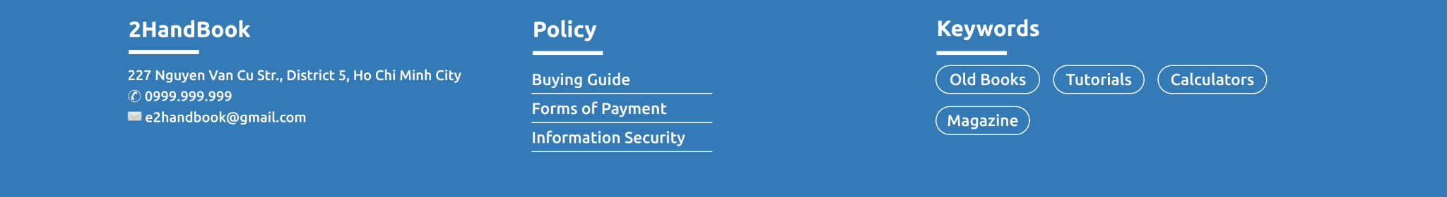

Description:

* Feature 1 (Policy): When pressing on any policy on this part, the system will display the “Support” screen respectively. (Buying Guide, Forms of Payment, Information Security).
* Feature 2 (Keywords): When clicking on any keyword from this list, the system will search and display the “Search Result” after search products by this keyword.

## Header (Logged In)



Description: After logged in, the header will display account button and announcement button instead of sign in button and sign up button.

* Feature 1 (account button): When pressing on the account button, the system will render and display the “Profile” screen.
* Feature 2 (announcement button): When pressing this button, the system will display all announcements of the logged in account as a pop-up (like “Announcement Box”).

## Cart

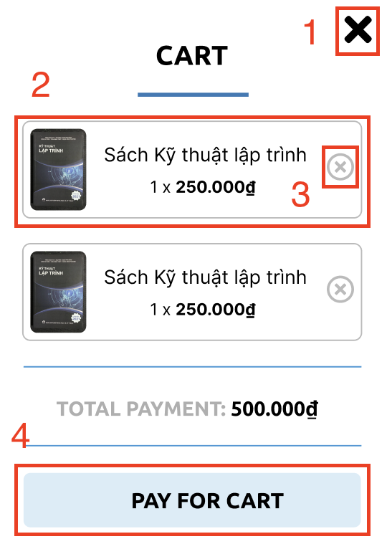

Description: After clicking on the cart button, the cart screen will slide from the right to the left. The user can see their products that they add to cart and the total money of them.

* Feature 1: The user can click on the close button to turn of the cart screen
* Feature 2: The user can click on the product card to move to the specific product page.
* Feature 3: The user can click on the delete button of each product item to remove this item from the cart.
* Feature 4: The user can click on the “Pay for cart” button to navigate to the Payment screen and buy them.

## Announcement Box

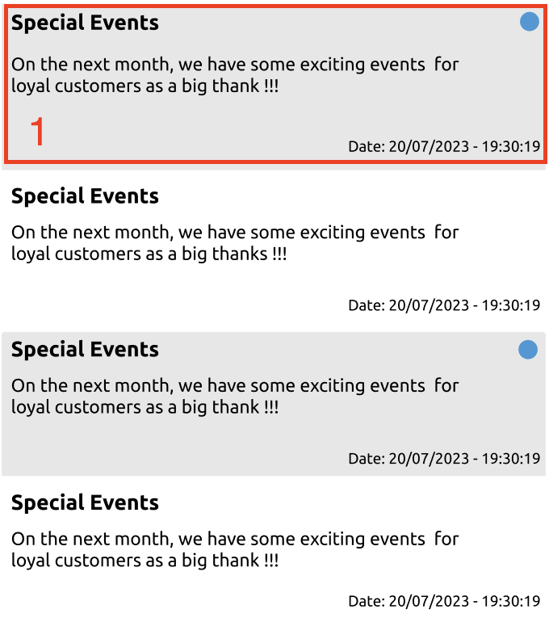

Description: After clicking on the announcement button with bell shape, the announcement screen will display and the user can see their notification information like title, content, date.

* Feature 1: The user can click on an unread notification to mark it as read.

# Screens

## Home

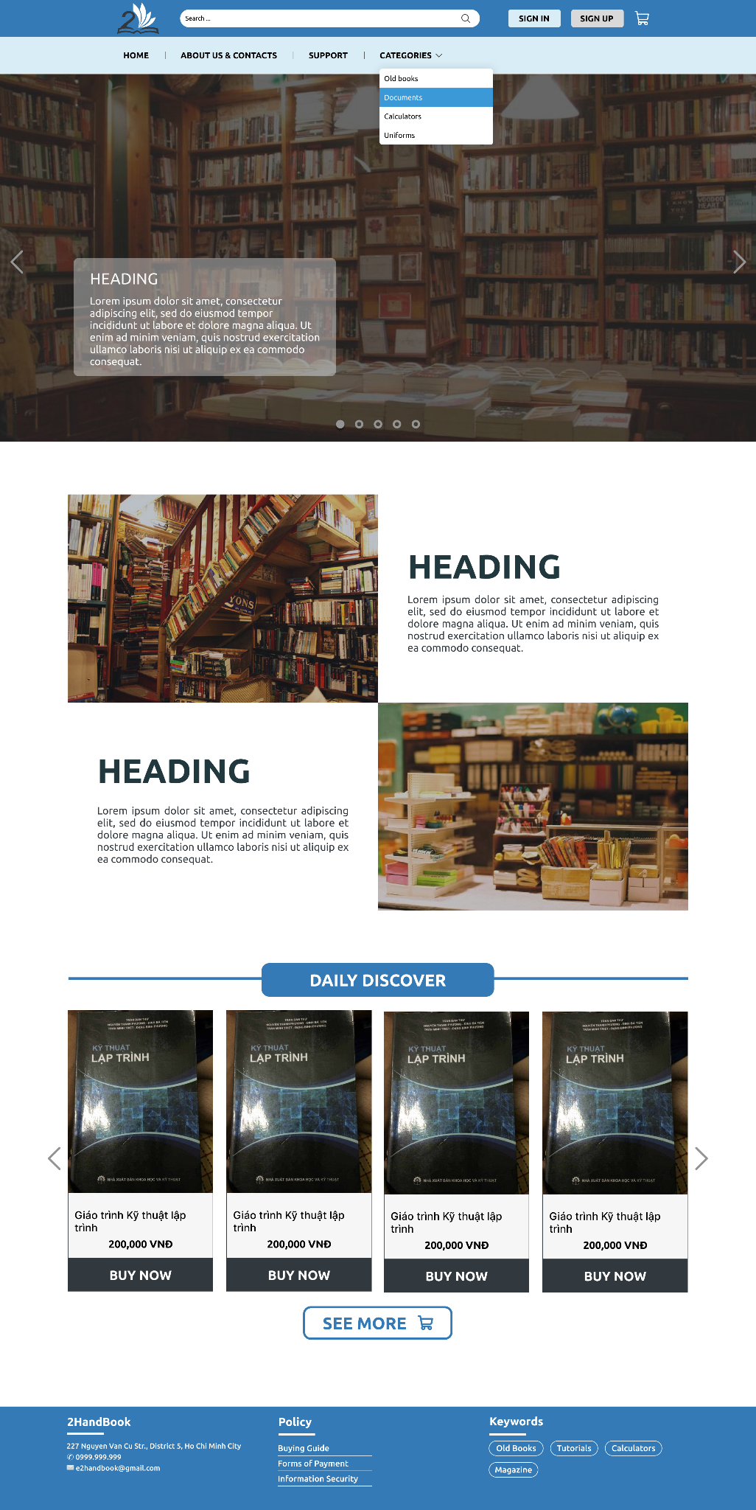

Description:

* Feature 1 (Slider): This is where the system displays important announcements or new products of the website.
* Feature 2 (Banner): This is where the main features of the website are displayed.
* Feature 3 (Daily Discover): This is where the system's latest trending products are displayed. When clicking on any product, the system will display that product page. (“Specific product” screen) When clicking the "See more" button, the system will display all the products of the system. (“All products” screen)

## Sign up

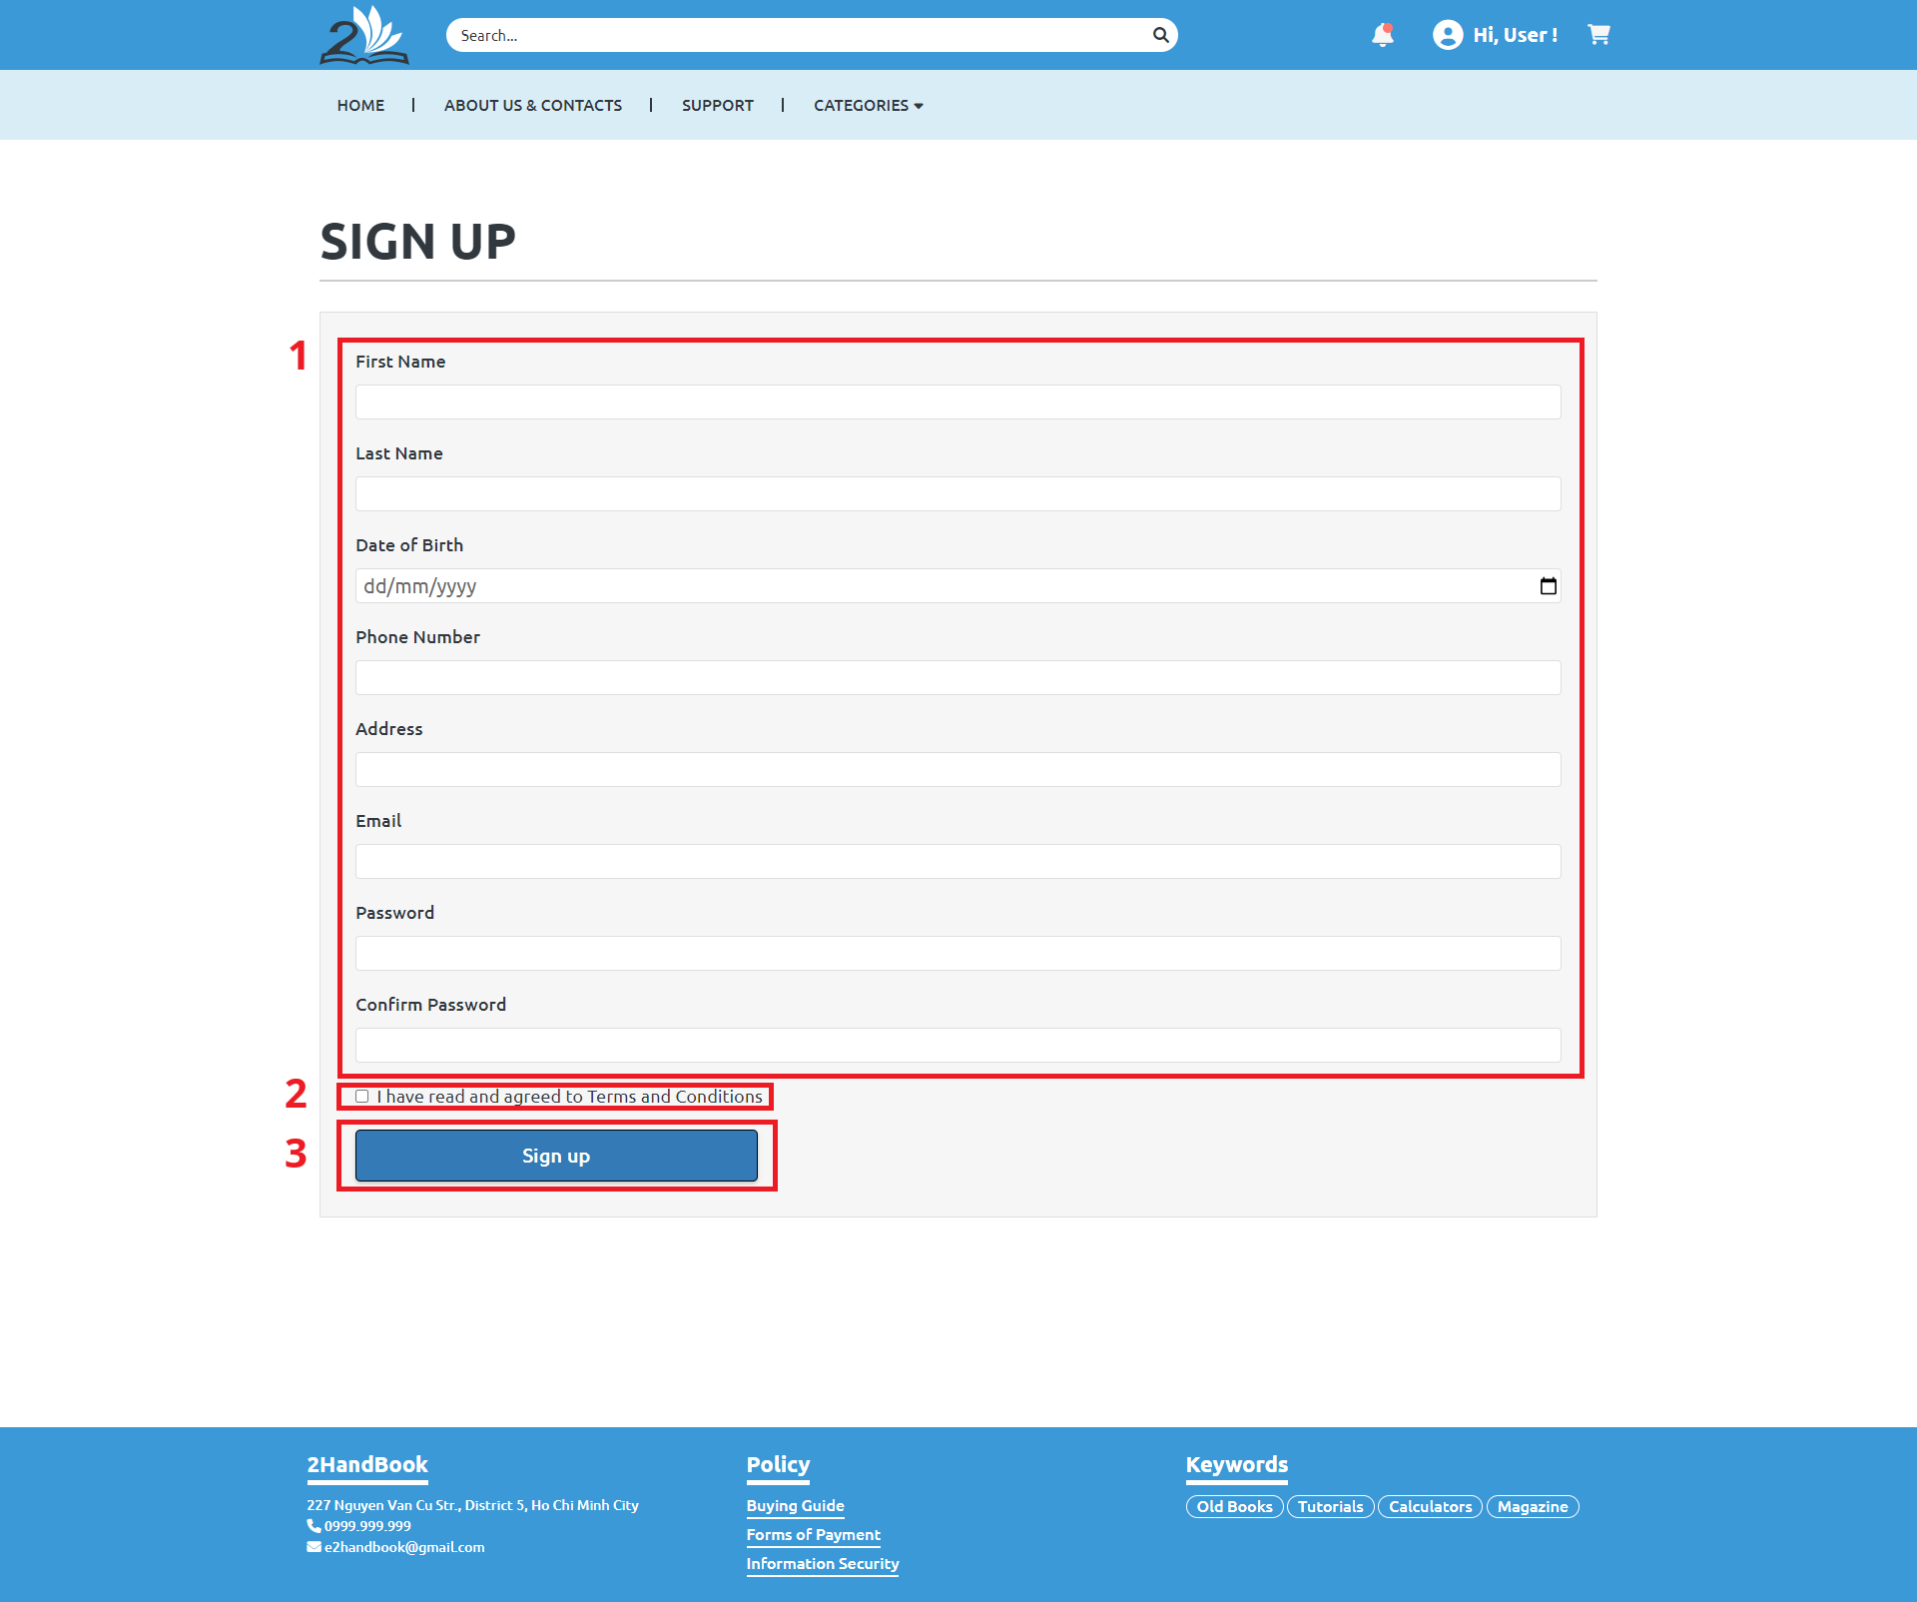

Description:

* Feature 1: The user fills in all the fields to provide account information.
* Feature 2: The user must check the box to agree to the website’s policies to be able to proceed.
* Feature 3: Lastly, the user clicks the Sign up button for the system to verify the information and then create an account if valid.

## Sign in

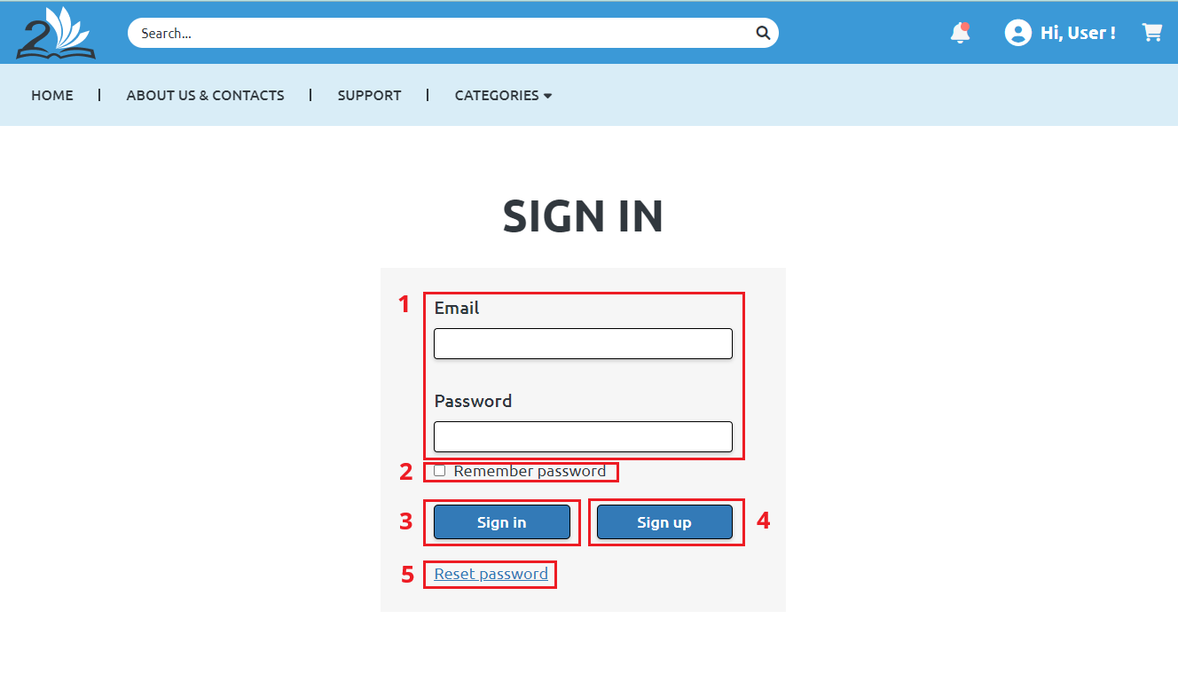

Description:

* Feature 1: The user fills in their Email and Password.
* Feature 2: (Optional) They can check the box to remember the password after signing in for better convenience for the next log in.
* Feature 3: After filling out the account, the user clicks Sign in for the system to authenticate.
* Feature 4: They can also click Sign up to create an account. This will bring them to the Sign up page (3.18)
* Feature 5: The user can click Reset password if they have forgotten their account or to change password. If clicked, there will be a form for the user to input their email address, and a password reset will be sent.

## Payment

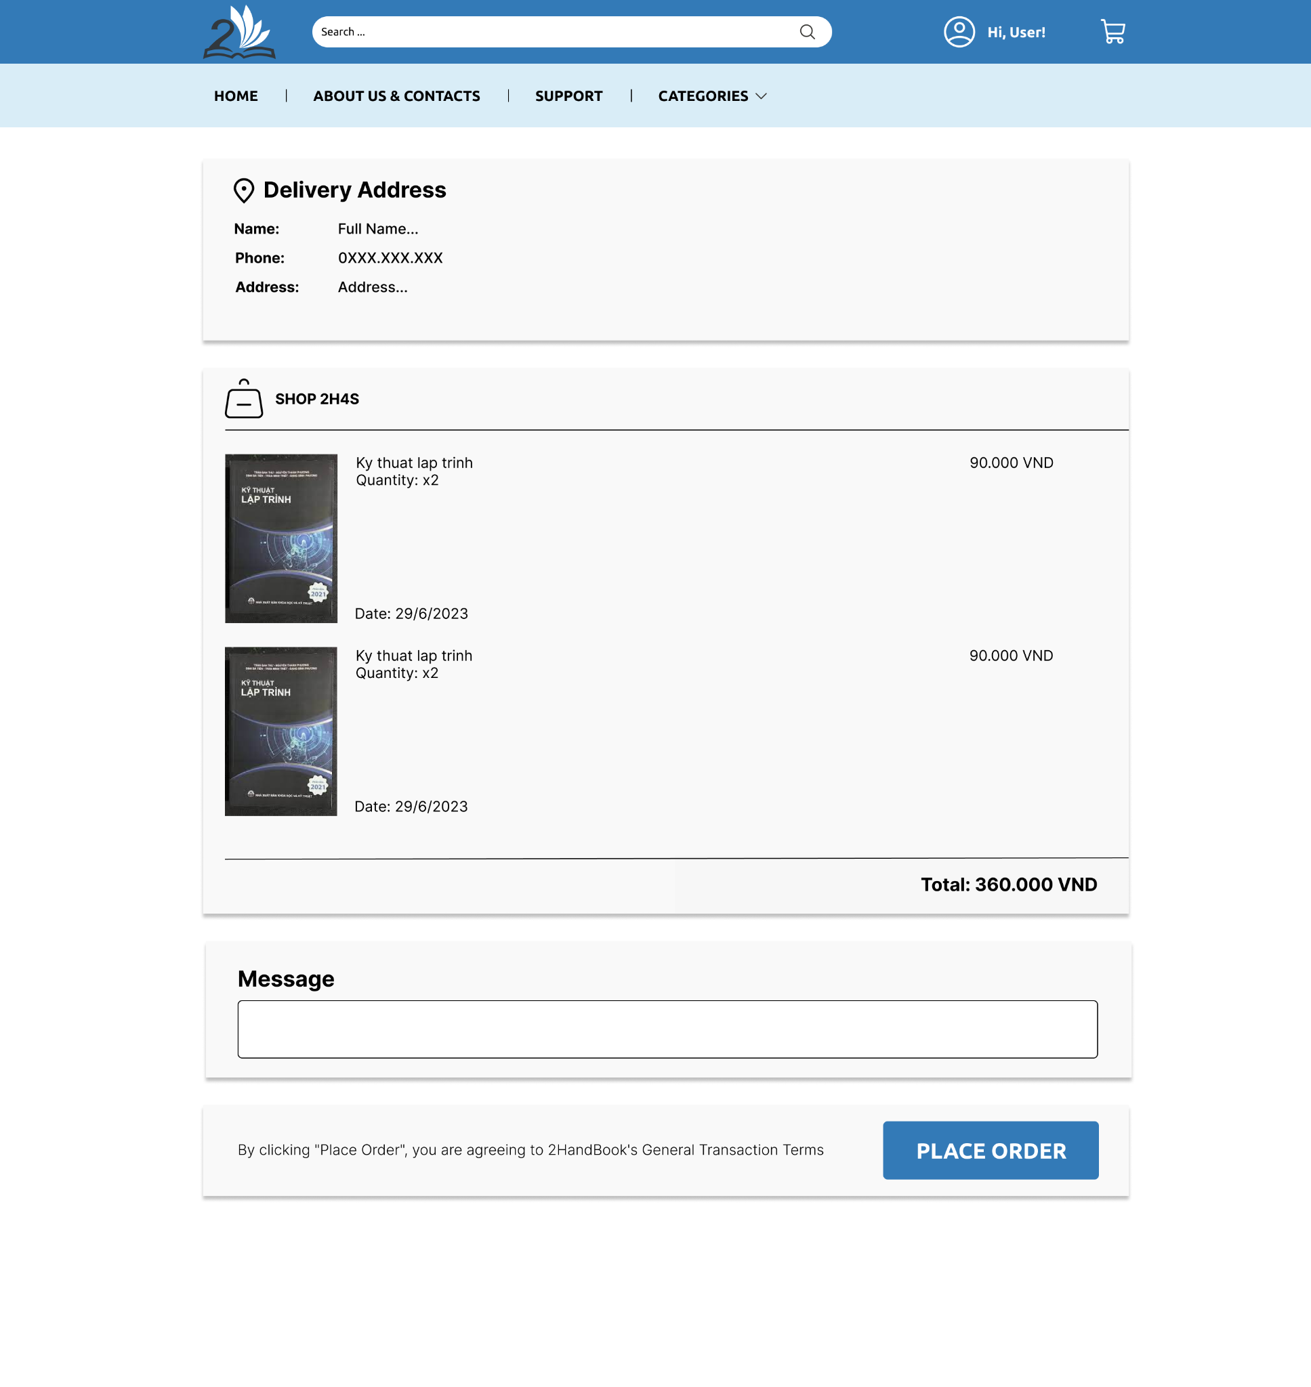

Description:

* Feature 1 (Information): The system will display some information including the buyer's name, address, phone number and order information such as (shop name, item, quantity, total amount...).
* Feature 2 (Message): Buyers enter the message they want to send to the seller in the "Message" box.
* Feature 3 (Place Order): When the "Place Order" button is pressed, the system will record the order information with the order status "Pending" and send it to the seller for processing.

## Announcement Handle (Admin)

### Post an announcement

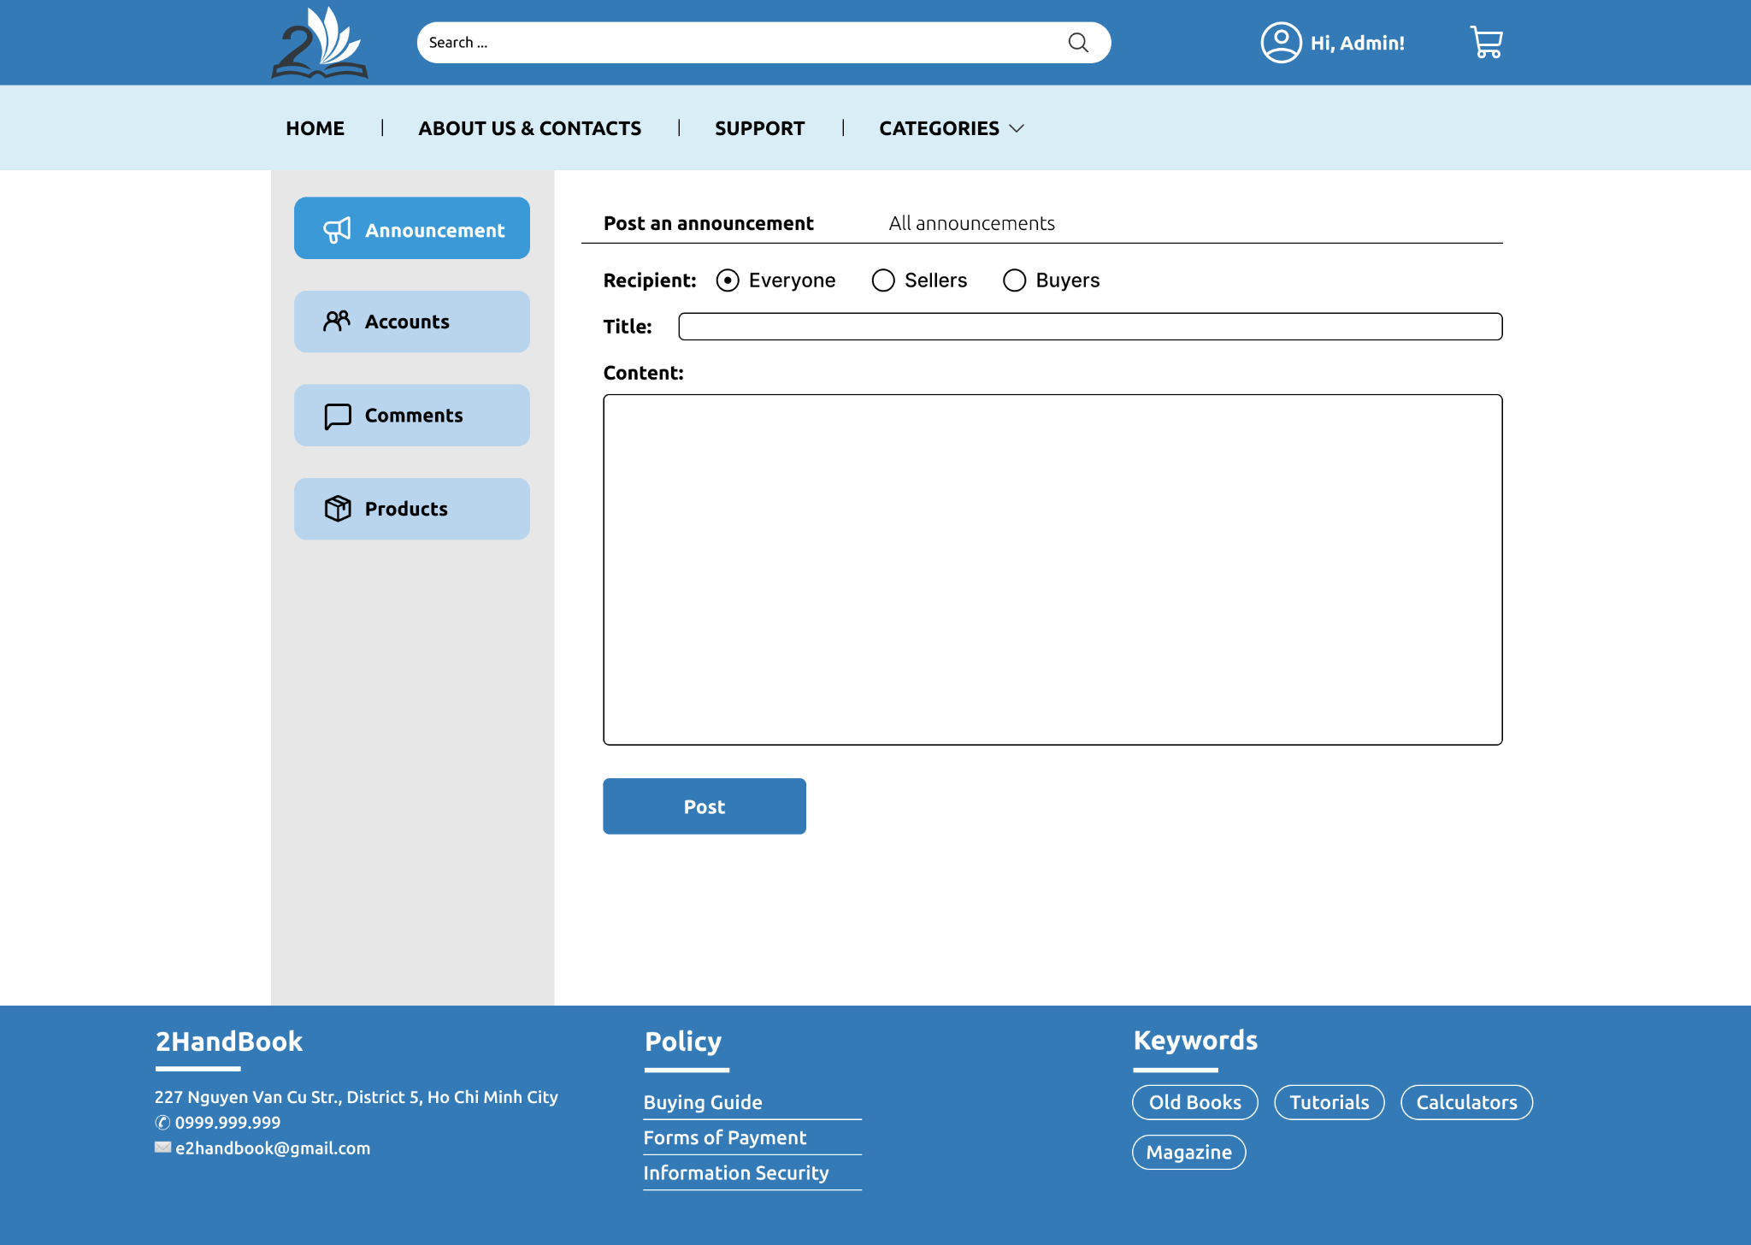

Description:

* Feature 1 (Sidebar): The system will display the items that the admin needs to manage such as notifications, accounts, products, reviews. When selecting any item, the system will display the corresponding information management page.
* Feature 2 (Navigation): The system will display the possible actions. With notifications is to post new announcements and view all notifications. When selecting any action, the system will display the screen to perform the corresponding operation.
* Feature 3 (Post an announcement): The user enters the form the necessary information for the message such as recipient, title, content. When "Post" is pressed, the system will send a notification to the corresponding recipient.

### All announcements

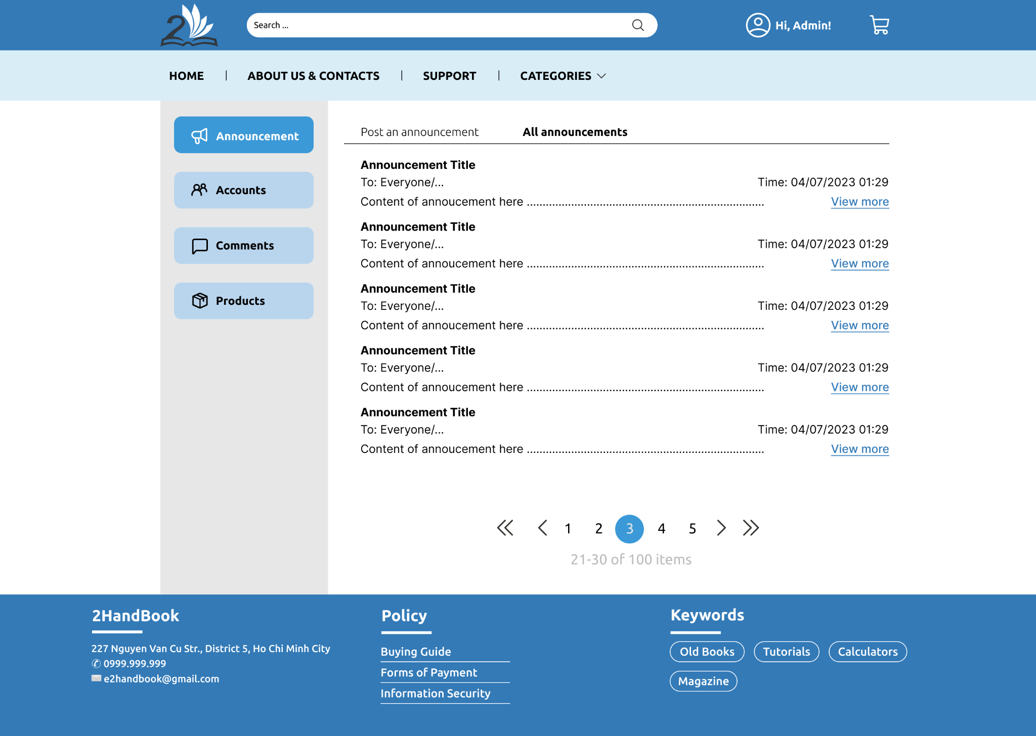

Description: All posted announcements are shown here. A page displays up to 10 messages. Each message includes basic information such as title, recipient, content, and time. When clicking the "View more" button, the system will display more complete content as shown below.

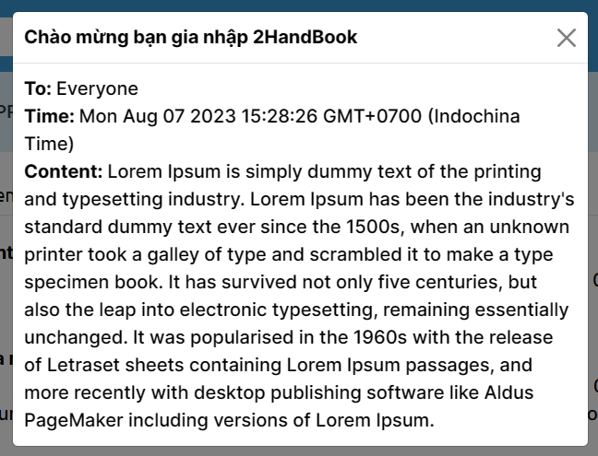

## Account Management (Admin)

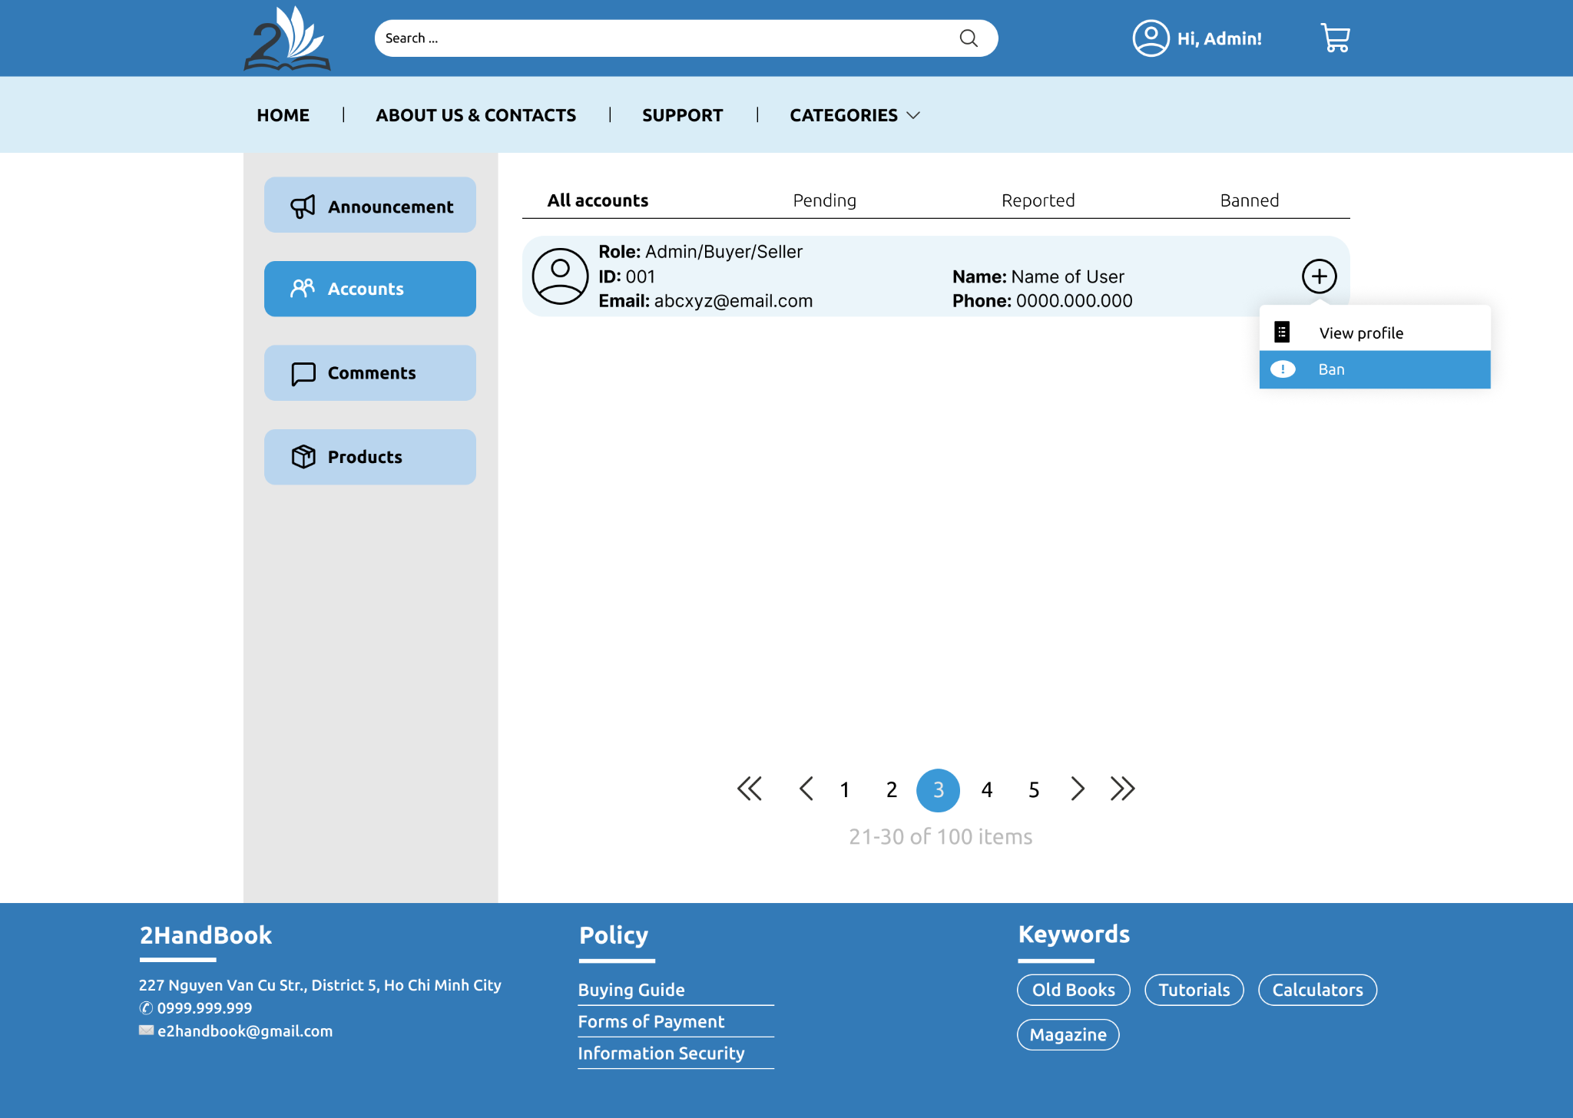

Description: All accounts are shown here with specific status. The displayed information of an account includes role, ID, name, phone number, Email. Clicking the "More" button at the top right of each account will bring up a menu. Click to perform any action, the system will perform and return the corresponding result.

## Product Management (Admin)

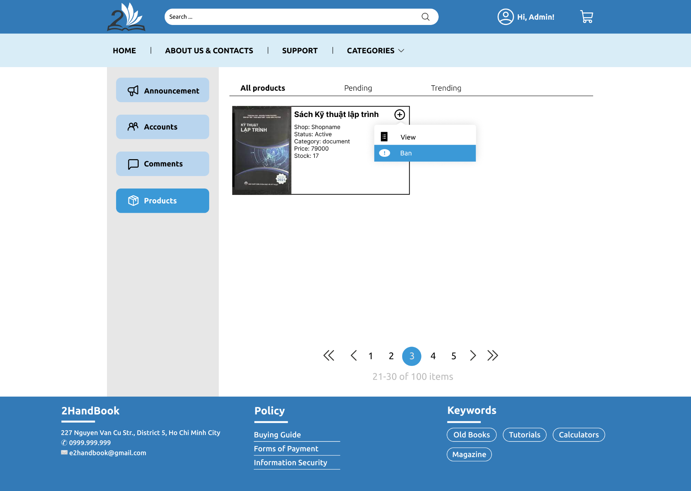

Description: All products are shown here with specific status. The displayed information of a product includes name, shop name, status, category, price, stock. Clicking the "More" button at the top right of each product will bring up a menu. Click to perform any action, the system will perform and return the corresponding result.

## Evaluate (Comment) Management (Admin)

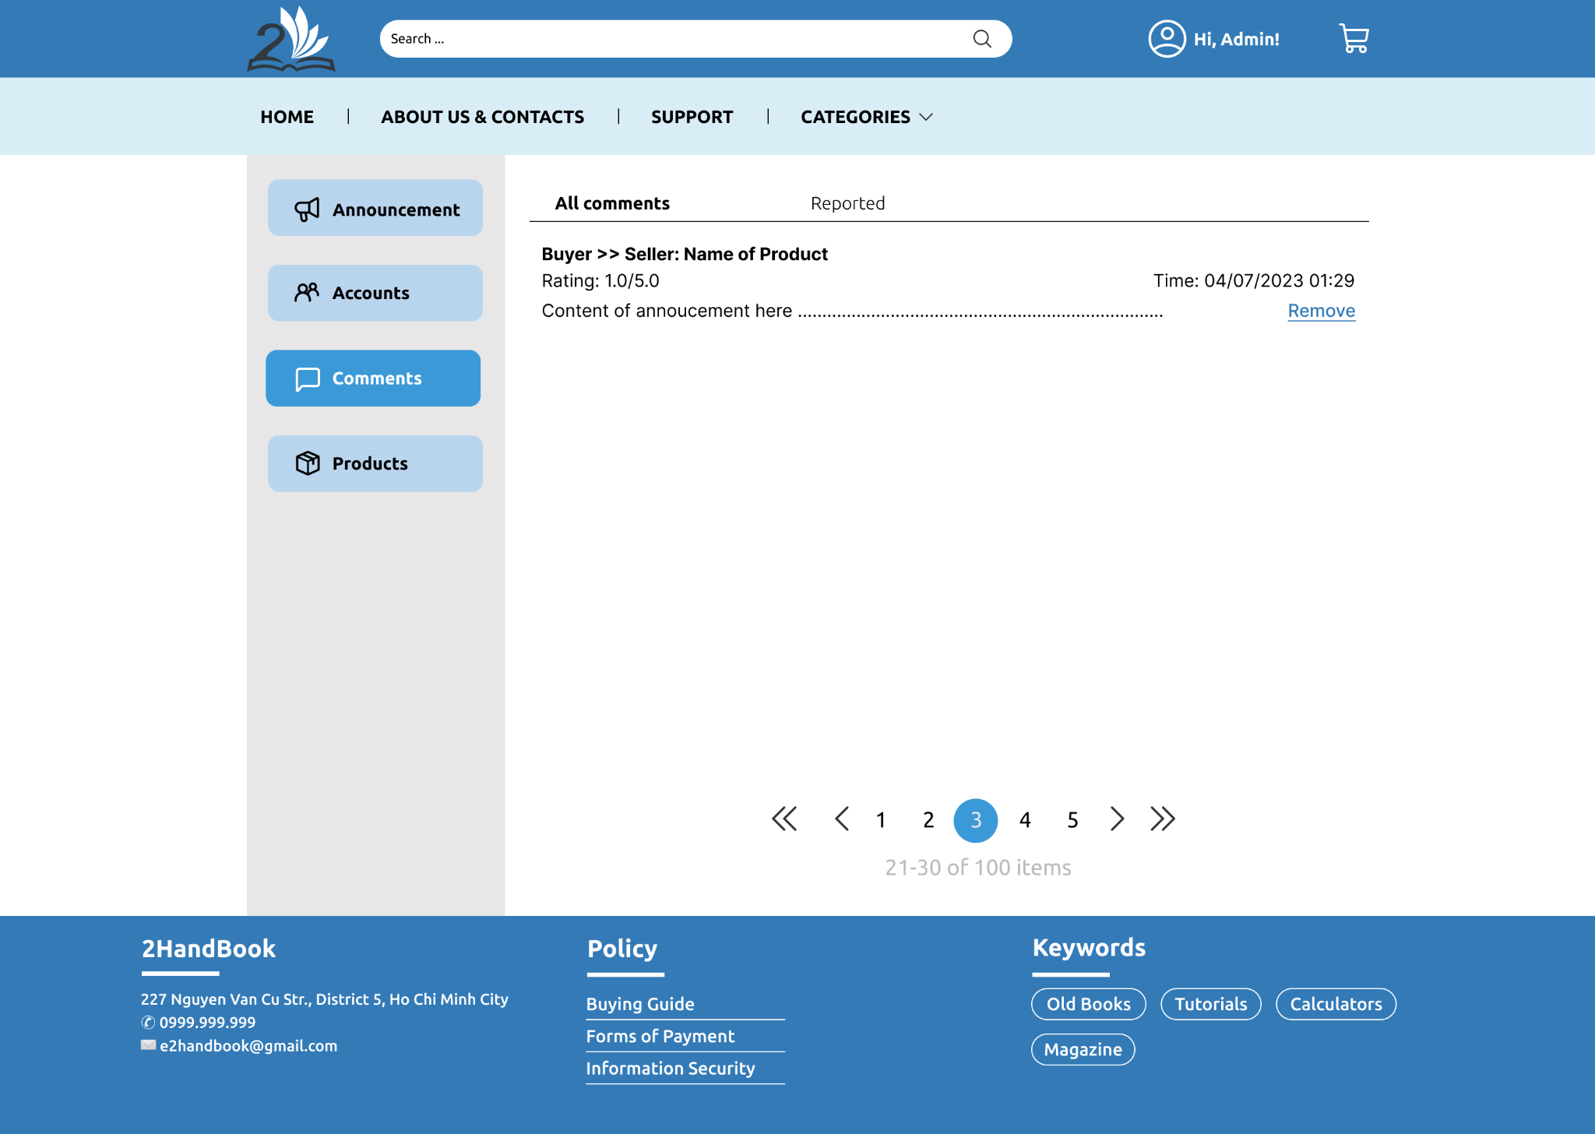

Description: All comments are shown here. A page displays up to 10 comments. Each message includes basic information such as product name, buyer, seller, rating, content, and time. When clicking the "Remove" button, the system will remove it from the database.

## All products

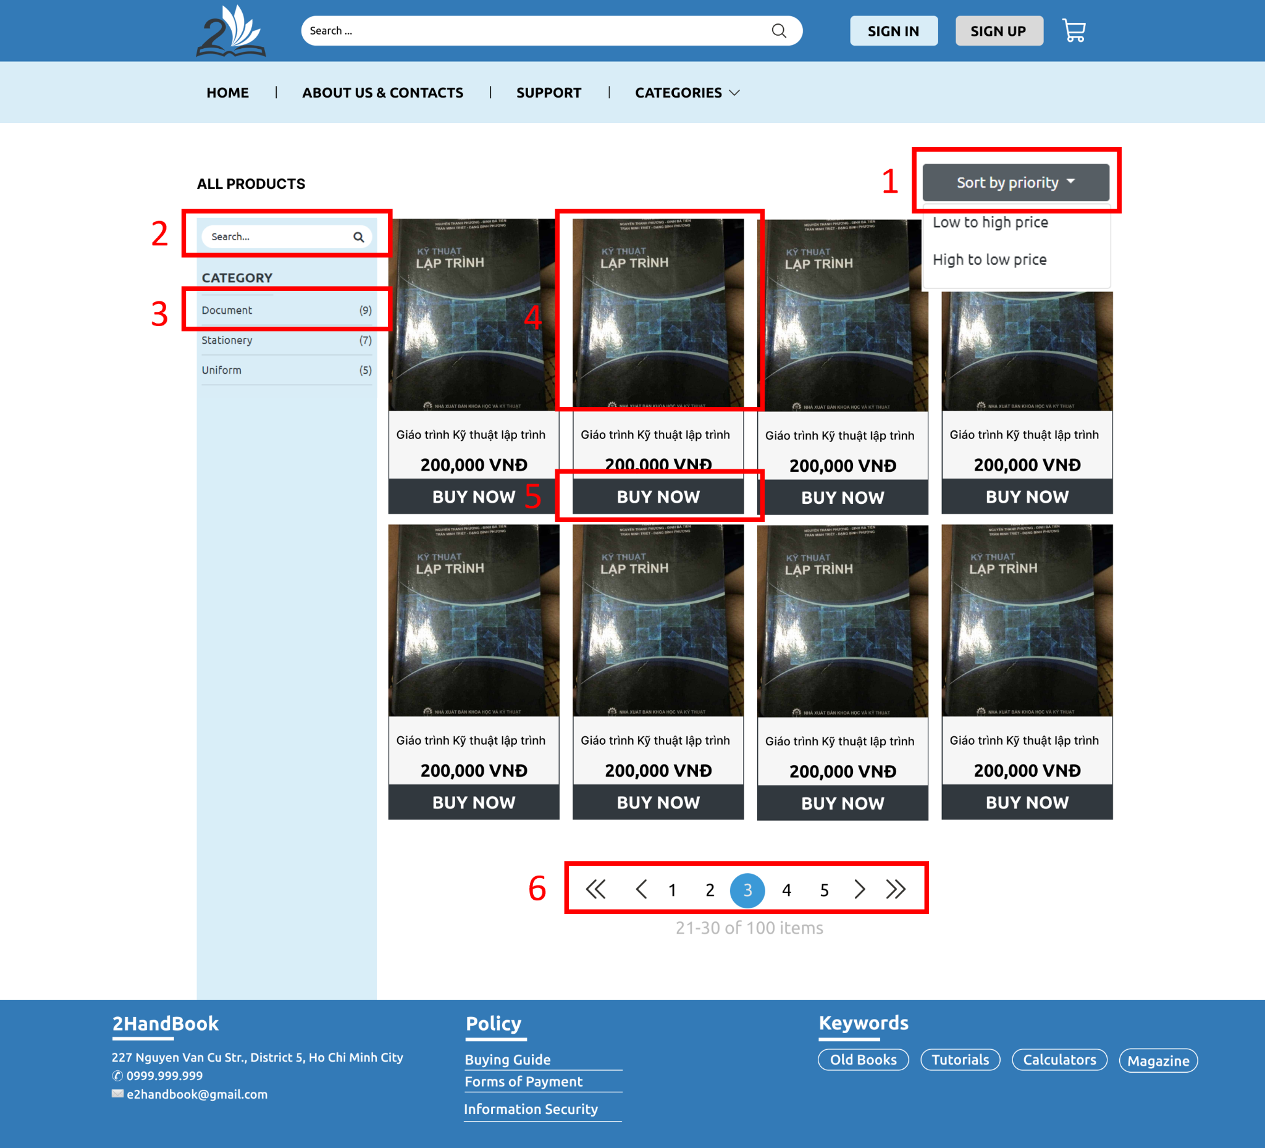

Description:

* Feature 1: The user can sort product by “low to high price” or “high to low price”
* Feature 2: The user can search any products which user intend to buy
* Feature 3: The user can find products by category
* Feature 4: When the user clicks on any product’s image, they will be linked to Specific product page of that product
* Feature 5: When the user clicks “BUY NOW” button, they will be linked to Specific product page of that product to adjust the quantity of the product before purchasing
* Feature 6: When the user clicks on any number on pagination bar, the page will emerge other products

## Specific products

## 

Description:

* Feature 1: When the user clicks on the “Report” button, a “REPORT” request about a product will be sent to the admin
* Feature 2: When the user clicks on the “View shop” button, they can visit the shop of the product being visited
* Feature 3: When the user clicks on the plus or minus button, the quantity of that product will be adjusted
* Feature 4: When the user clicks on the “ADD TO CART” button, a product will be moved to their carts.
* Feature 5: When the user clicks on the “BUY NOW” button, they will be linked to the payment page
* Feature 6: The user can comment on the text box, and they have to press on the Enter key or click on the “SEND” to post their comments.
* Feature 7: When the user clicks on the “Report” button, a “REPORT” request about a comment will be sent to the admin
* Feature 8: When the user clicks on any product’s image, they will be linked to Specific product page of that product
* Feature 9: When the user clicks “BUY NOW” button, they will be linked to Specific product

## Profile editing

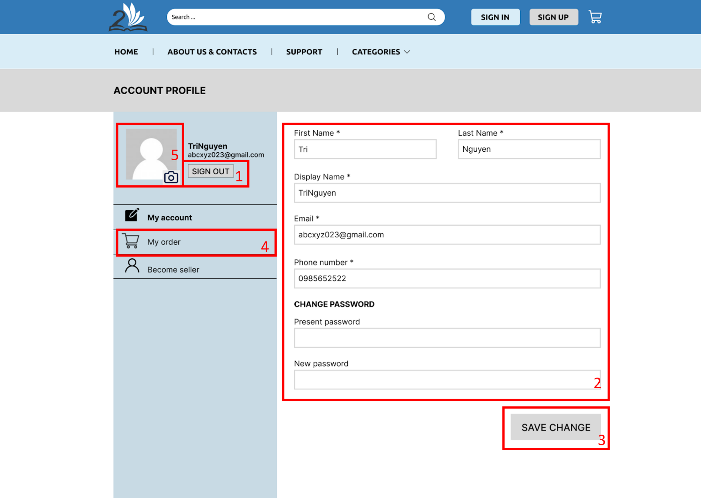

Description:

* Feature 1: The users can sign out by clicking on button “SIGN OUT”.
* Feature 2: The users can edit or update their profile.
* Feature 3: The users click the “SAVE CHANGES” button to save their changes of profile.
* Feature 4: The users click “My order” or “Become seller” section to switch to corresponding pages.
* Feature 5: The users can change avatar by clicking to avatar and choose image from computer.

## My order

### Successful order

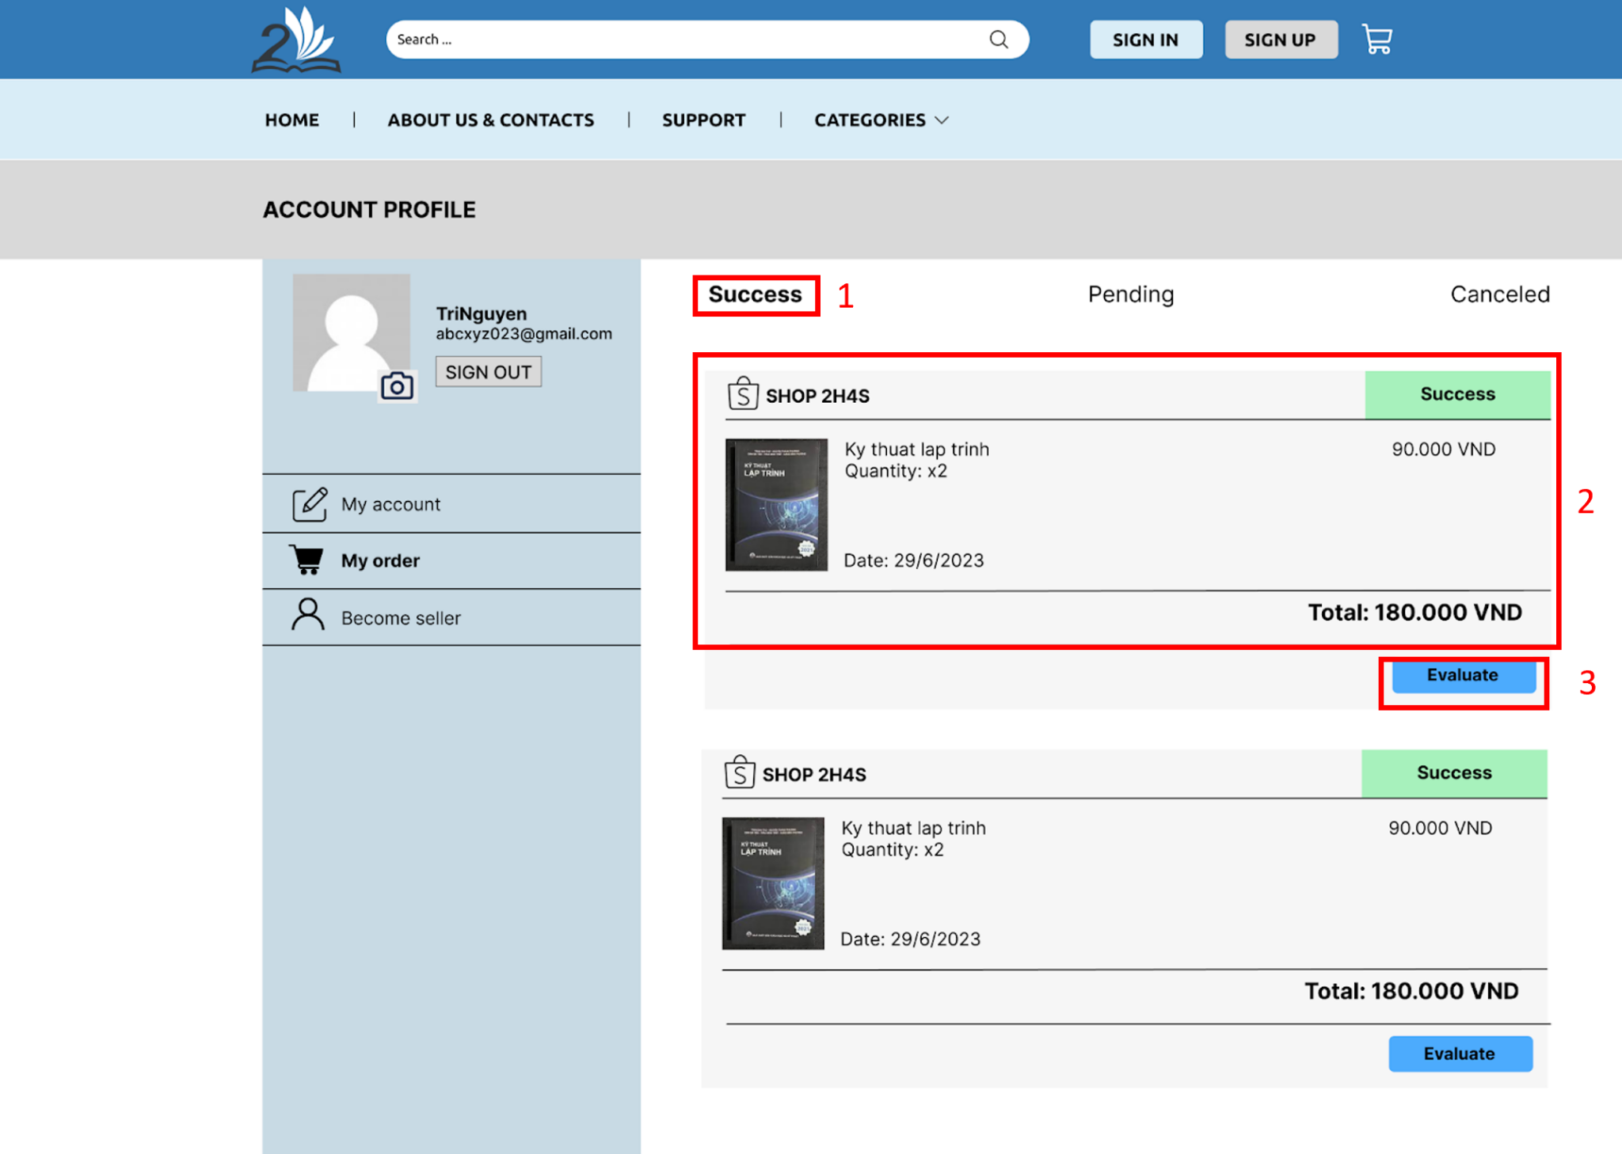

Description:

* Feature 1: The users click the “Success/Pending/Canceled” section to switch to corresponding status of products (Success, Pending, Canceled).
* Feature 2: The users click on this section to go to the specific page of the product.
* Feature 3: After clicking the “Evaluate” button, a form will be displayed as a modal, then the users can fill in the form to evaluate that product:

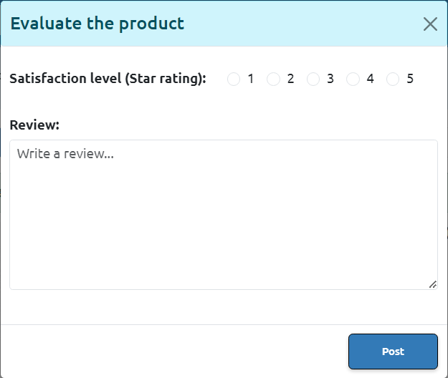

### Pending order

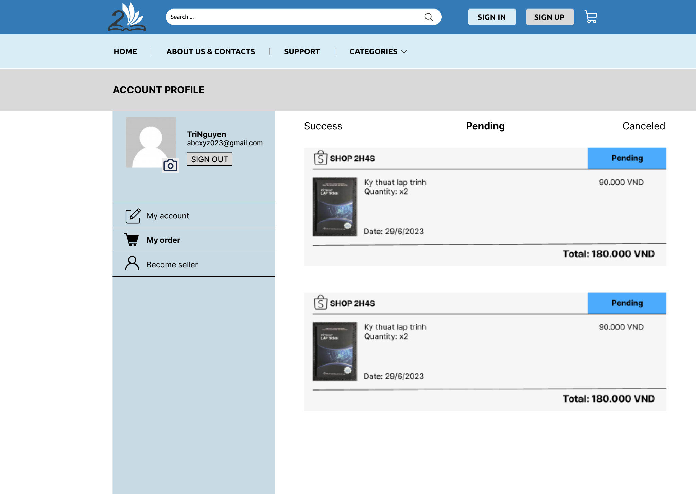

Description: the features are almost the same as the order success page except for the product evaluation feature because the orders are pending.

### Canceled order

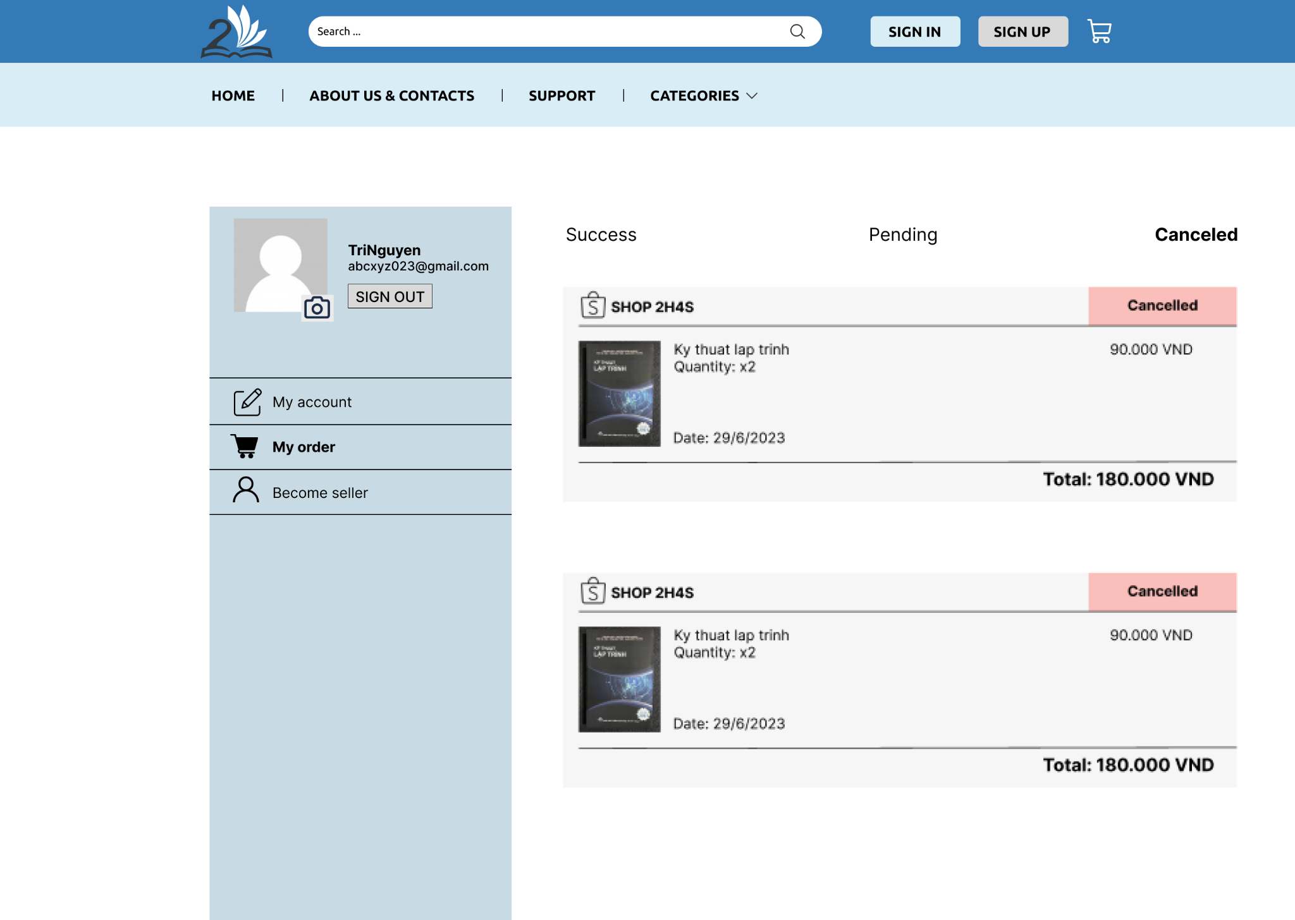

Description: the features are almost the same as the order success page except for the product evaluation feature because the orders are canceled.

## Become seller (Buyer)

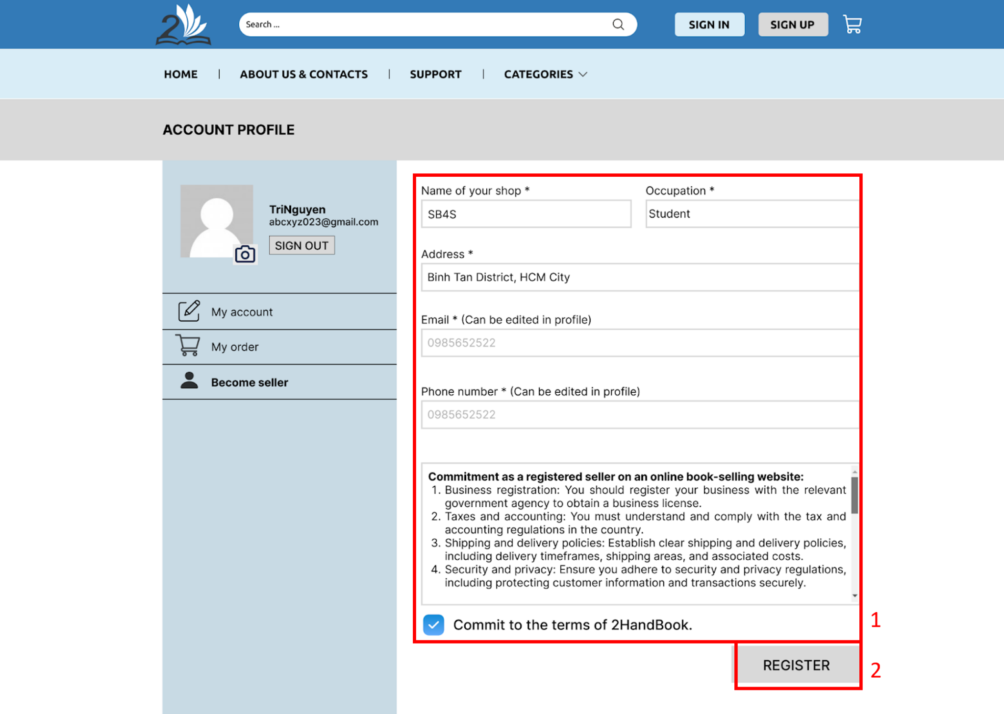

Description:

* Feature 1: The users can fill the form to request to become a seller.
* Feature 2: The users click on the “REGISTER” button to submit the request. Then the right section of this page will display the following text:  
  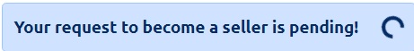

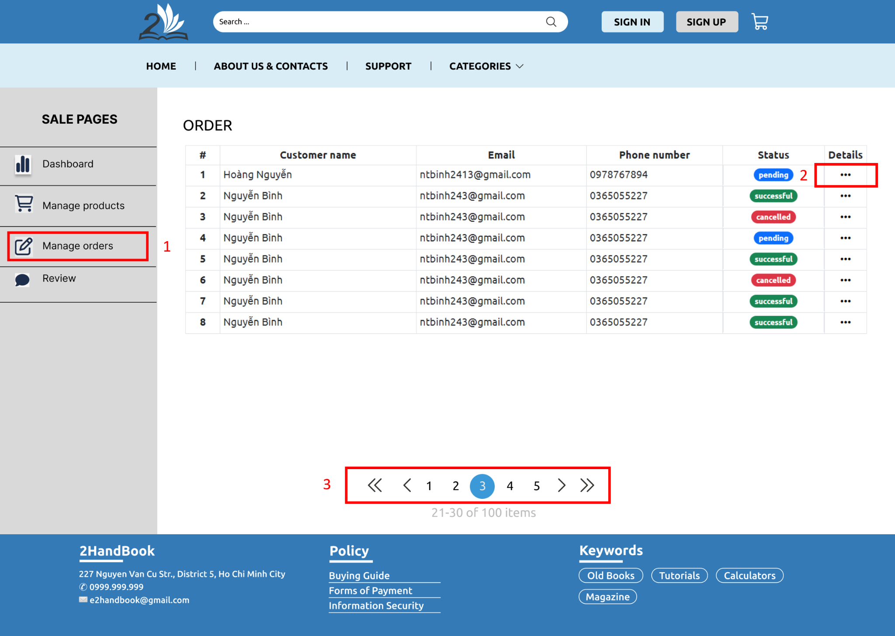

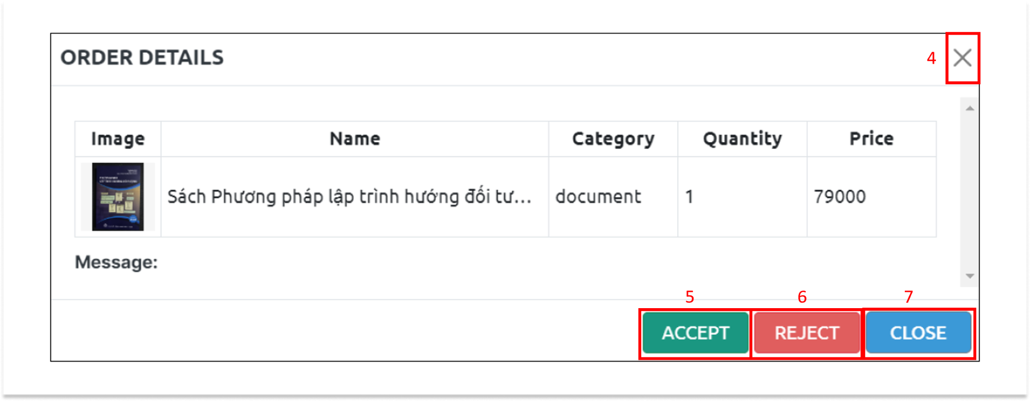

Description:

* Feature 1: When the seller clicks on the “Manage orders” tab on sidebar, they will be linked to the “Manage orders” page
* Feature 2: When the seller clicks on the ellipse button, a popup will appear for the seller to choose “ACCEPT” or “REJECT” for orders
* Feature 3: When the seller clicks on any number on pagination bar, the page will emerge other orders
* Feature 4: When the seller clicks on the “EXIT” button, popup will close
* Feature 5: When the seller clicks on the “ACCEPT” button, the order will be accepted
* Feature 6: When the seller clicks on the “REJECT” button, the order will be rejected
* Feature 7: When the seller clicks on the “CLOSE” button, popup will close

## Shop reviews (Seller)

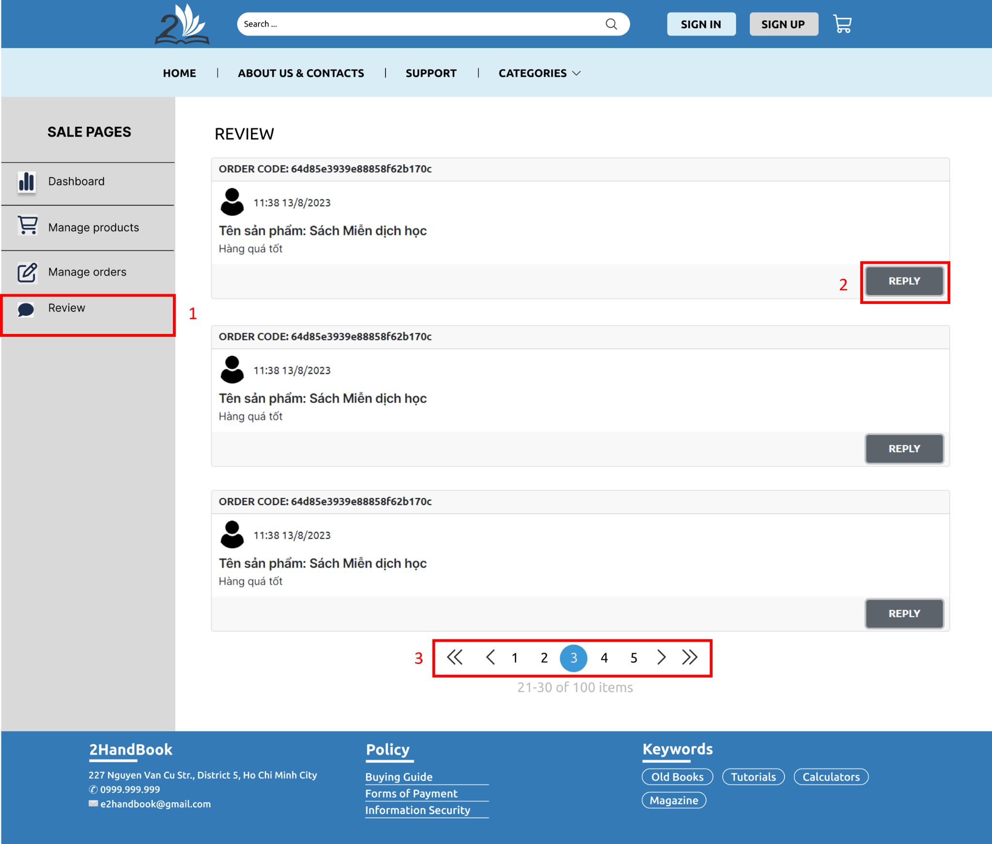

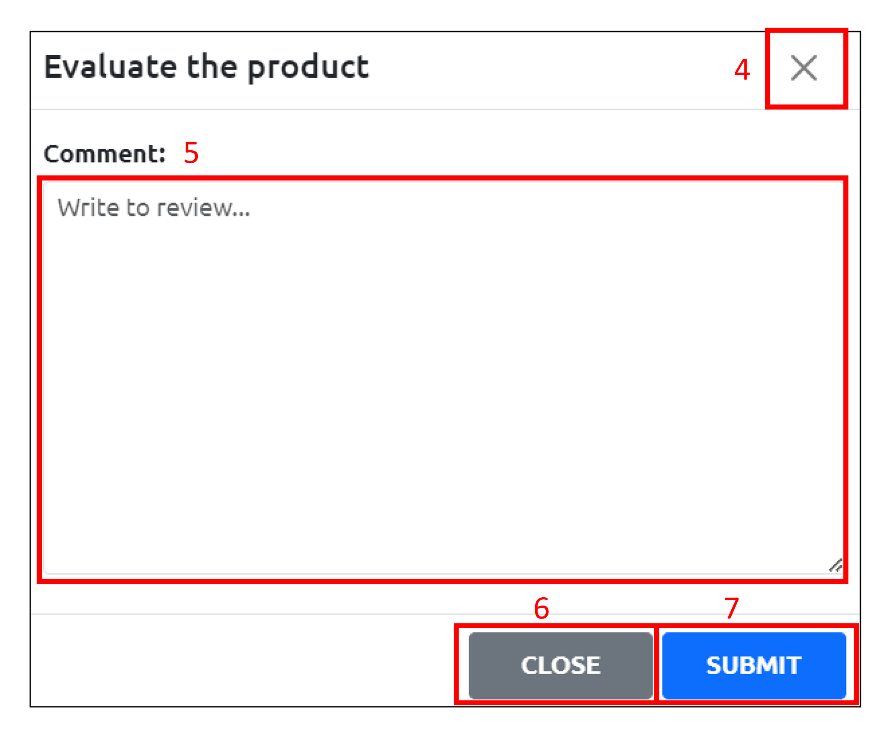

Description:

* Feature 1: When the seller clicks on the “Review” tab on sidebar, they will be linked to the “Shop reviews” page
* Feature 2: When the seller clicks on the “REPLY” button, a popup will appear for the seller to reply comments from their customers
* Feature 3: When the seller clicks on any number on pagination bar, the page will emerge other orders
* Feature 4: When the seller clicks on the “EXIT” button, popup will close
* Feature 5: The user can comment on the text area above to express their opinions
* Feature 6: When the seller clicks on the “CLOSE” button, popup will close
* Feature 7: When the seller clicks on the “SUBMIT” button, the reply from the shop will appear in the comment section of the product

## Dashboard (Seller)

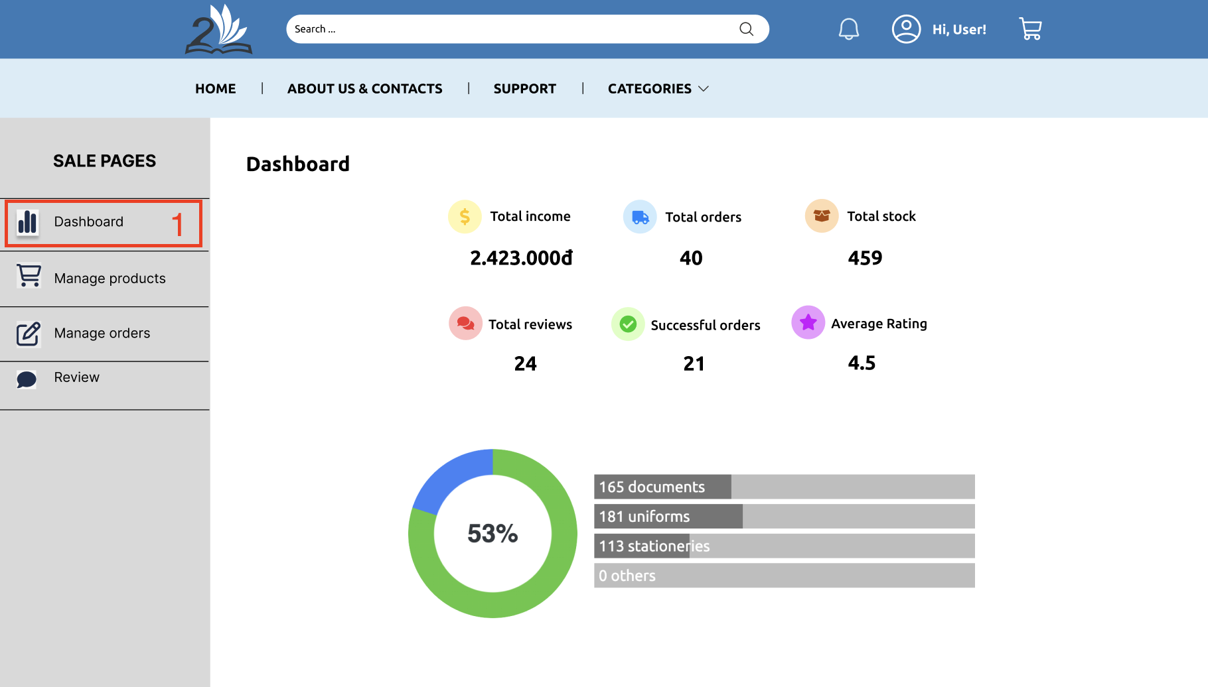

Description:

* Feature 1: When the seller clicks on the “Dashboard” tab on the sidebar, they will be linked to the “Dashboard” page. At this page, the user can see some statistical information about their shop like total income, total orders, etc.

## Manage products (Seller)

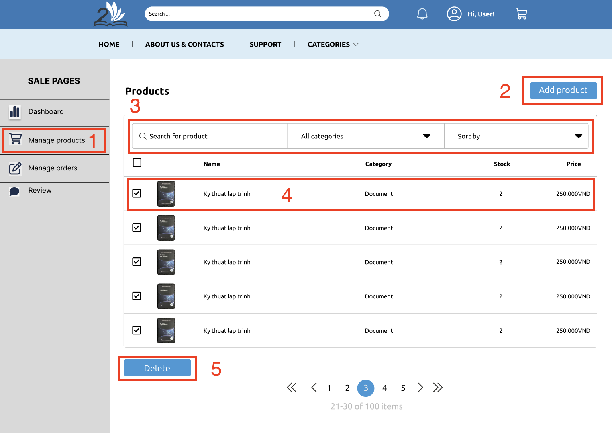

Description:

* Feature 1: When the seller clicks on the “Manage products” tab on the sidebar, they will be linked to the “Manage products” page.
* Feature 2: The seller can click on the “Add product button” to add a new product
* Feature 3: The seller can use the “manage product” bar for easily managing. This bar includes search for product, filter category and sort by a particular criteria.
* Feature 4: The seller can click on the product item to navigate to the “Edit product” page
* Feature 5: The seller clicks on the delete button to delete all of the checked products.

## Edit product (Seller)

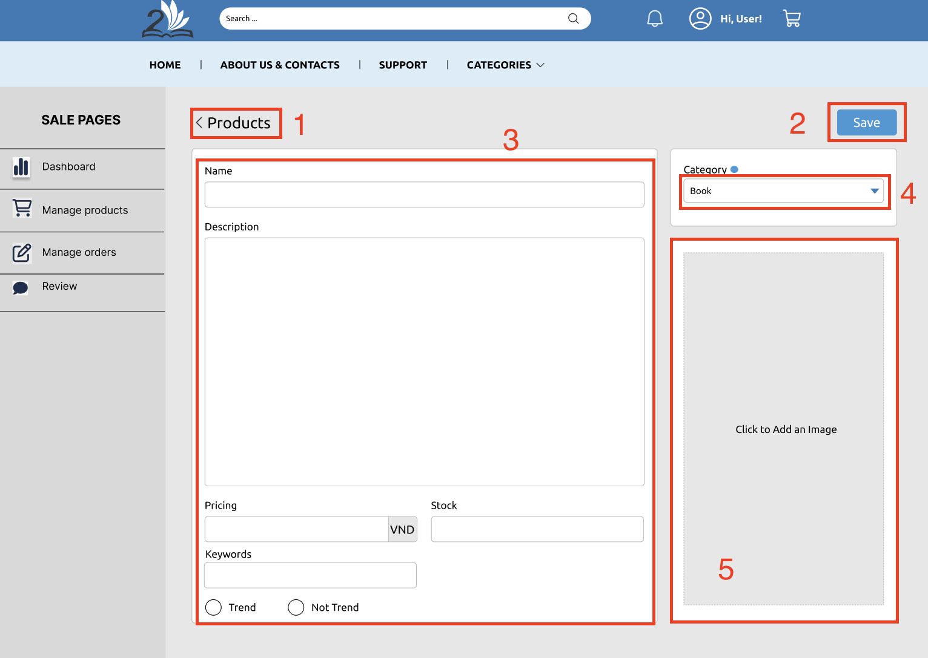

Description:

* Feature 1: When the seller clicks on the “Products” breadcrumb, they will be linked back to the “Manage products” page.
* Feature 2: The seller can click on the “Save” button to save their new product information.
* Feature 3: The seller fill in all product information forms
* Feature 4: The seller selects one of the categories.
* Feature 5: The seller can click, drag or drop to select the product image.

## About us & Contacts

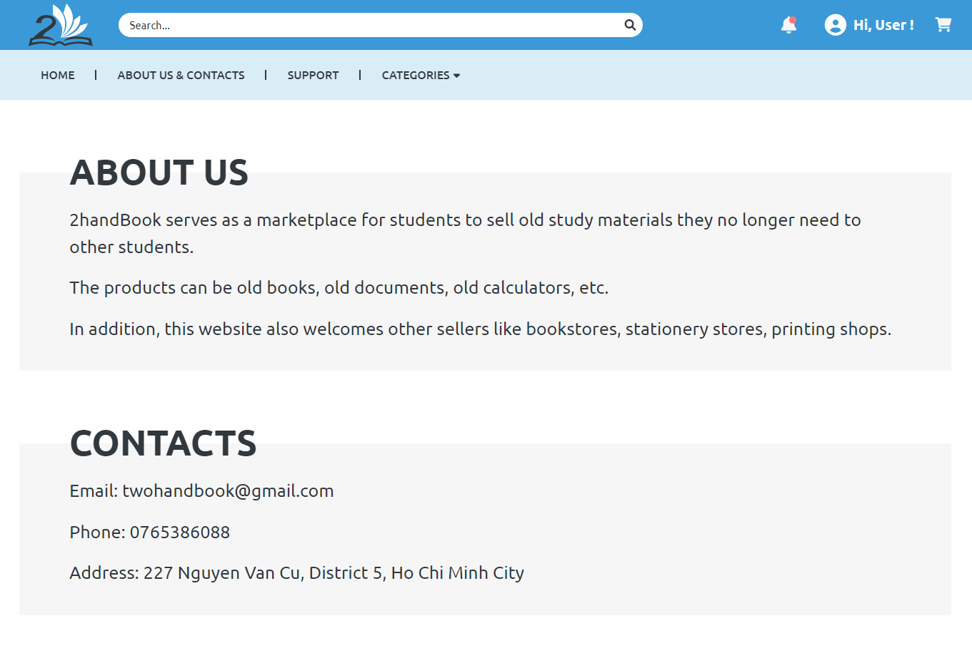

Description: This page provides basic information about the website including its purpose and contact information.

## Shop page

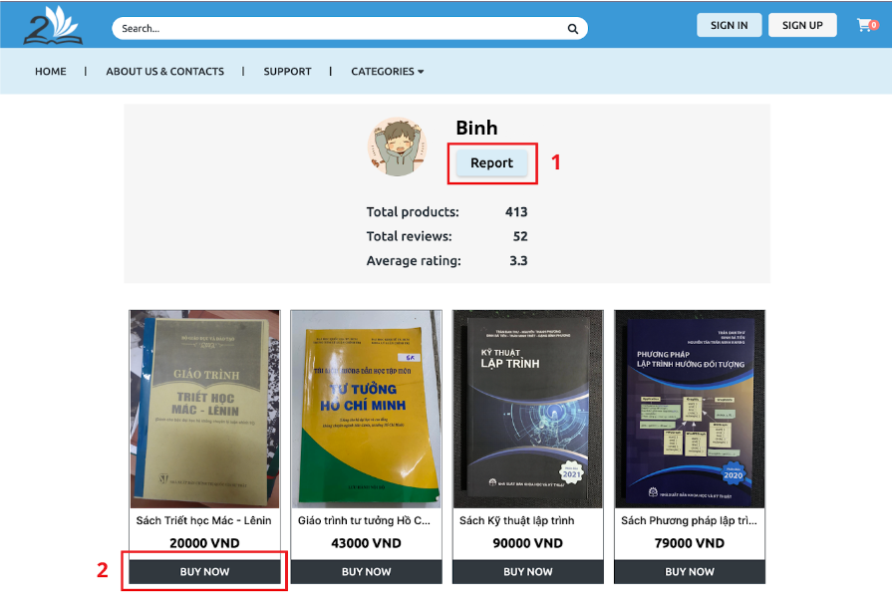

Description: This page provides basic information about a shop (seller) including Total products, Total views, Average rating, its products.

* Feature 1: The user can click the Report button to alert the admin about possible suspicious activities of the seller.
* Feature 2: The user can click BUY NOW on any product of the seller to go to the according product page to see in detail.